**RS1949 - AutoMap (HG38)**

**RS1949 - Homozygosity Mapper**

**RS2290 - AutoMap (HG38)**

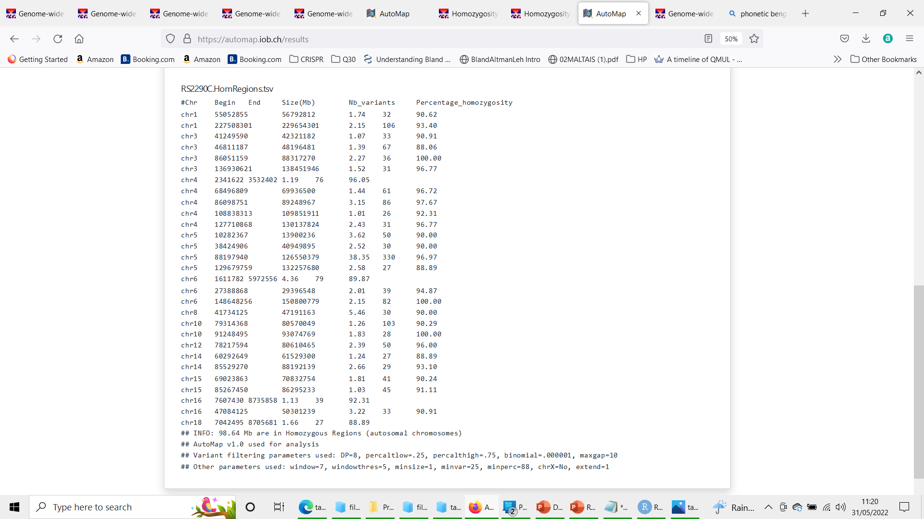

**RS2290 - Homozygosity Mapper**

**RS2012 - AutoMap (HG38)**

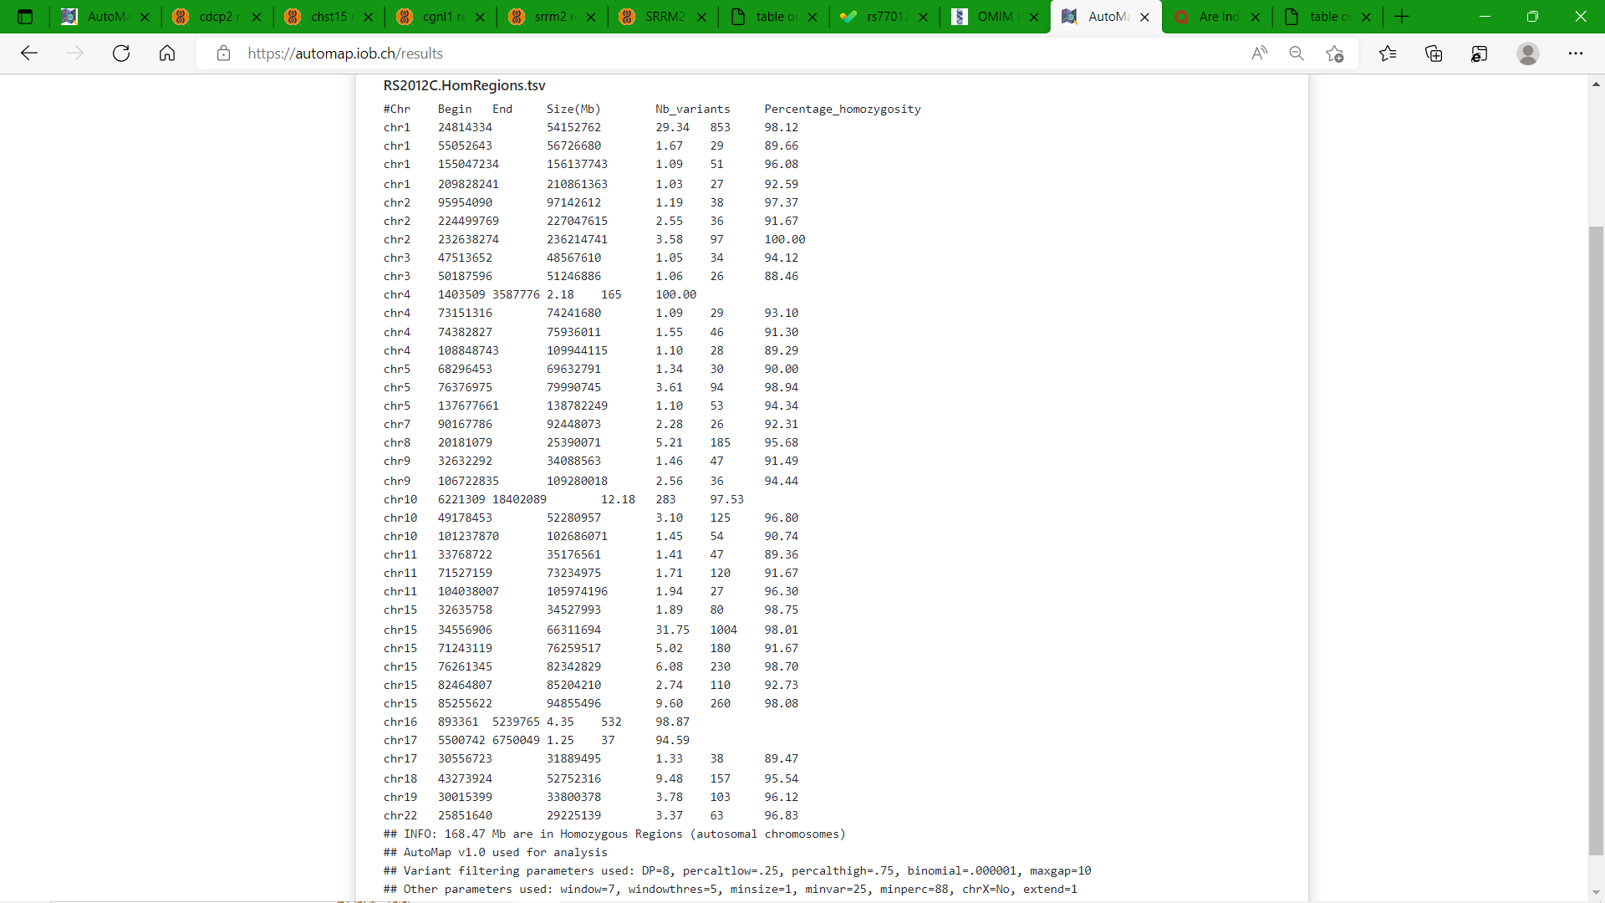

**RS2012 - Homozygosity Mapper**

**RS2210 - AutoMap (HG38)**

**RS2210 - Homozygosity Mapper**

**RS2247 - AutoMap (HG38)**

**RS2247- Homozygosity Mapper**

**RM4426 - AutoMap (HG38)**

**RM4426 - Homozygosity Mapper**

**RS2021 - AutoMap (HG38)**

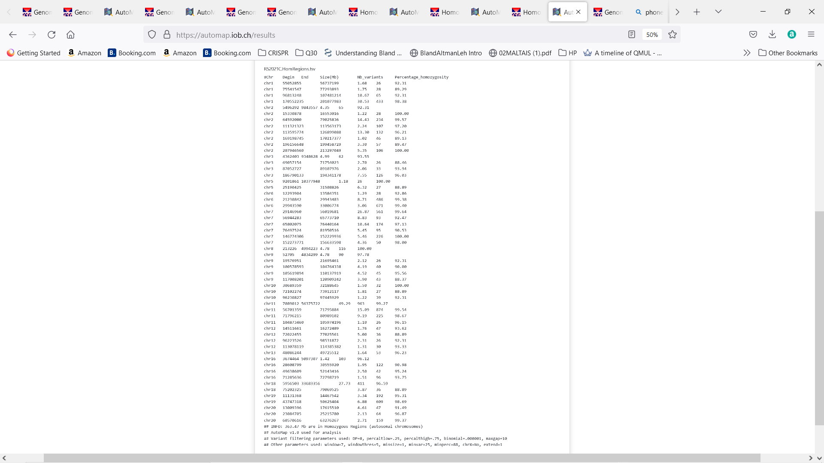

**RS2021 - Homozygosity Mapper**

**RS1901- AutoMap (HG38)**

**RS1901 - Homozygosity Mapper**

**T3-ST-12 - AutoMap (HG38)**

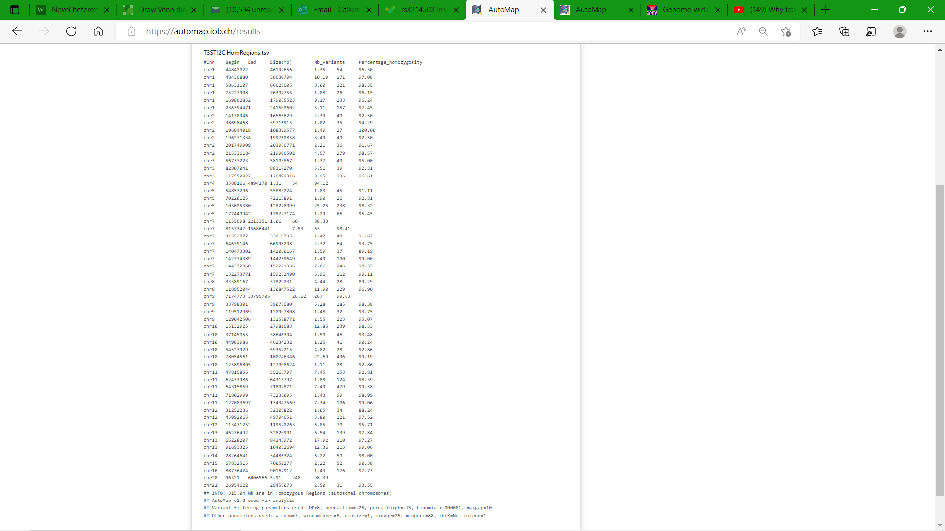

**T3-ST-12 - Homozygosity Mapper**

**RS1048 - AutoMap (HG38)**

**RS1048 - Homozygosity Mapper**

**RS2326 - AutoMap (HG38)**

**RS2326 - Homozygosity Mapper**

**RS2320 - AutoMap (HG38)**

**RS2320 - Homozygosity Mapper**

**RS2278 - AutoMap (HG38)**

**RS2278 - Homozygosity Mapper**

